**Explanation:** This lab will show the steps of setting up an Enumeration Statement. The enumeration statement lets you define a large number of variables in one spot. These variables each have their own number value. These number values don’t need to be remembered however because when you name an element within an enum statement the name you assign automatically replaces the number. This number still stays in the background so theoretically you could still call the value by its assigned number. The enum statement essentially takes the place of naming a large number of string variables at the top of a form. It consolidates it into one place and makes it a bit easier to call upon later in the program.

**Goal: Use an enum statement to change the background color and Label text of a windows form.**

**Required Controls:** Five (5) Buttons, One (1) Label

**Step 1)**

* Create a Windows Form Project.
* Add the controls listed above from the toolbox.
* Arrange as shown:

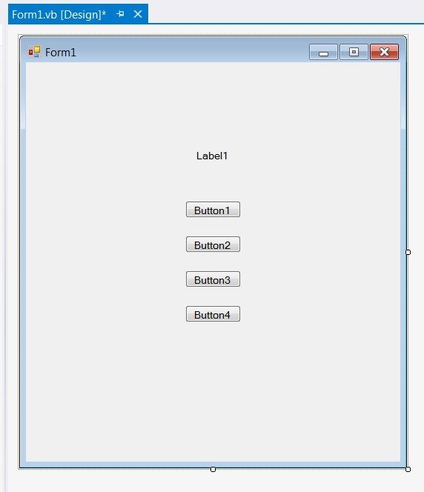

* Rename the buttons btn1, btn2, btn3, and btn4.
* Delete the text in the label.
* Change the text in the buttons as shown:

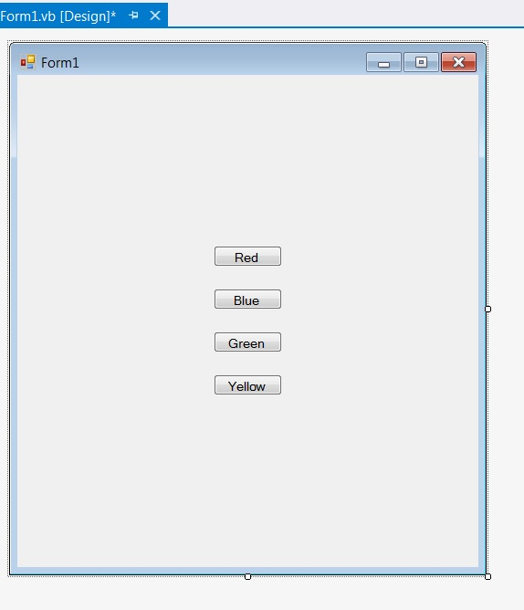

**Step 2)**

* Double click on the window to open the form1 code.
* Clear the automatically generated code snippet.
* Add the following code:

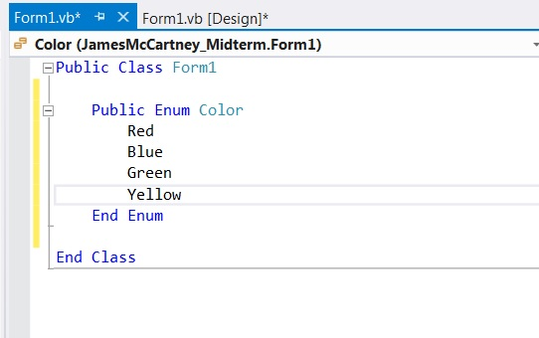

This has now set up the enumeration.

**Step 3)**

Now that the enum statement has been set up and the controls are on the window we need to be able to make them work together.

* We first need to create a new Sub routine that will interact with the enum statement.

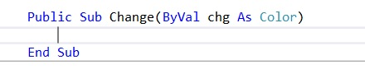

* Next, we need to write in the code that will take the enum value and pass is to something that can change the background color. We do that with the following: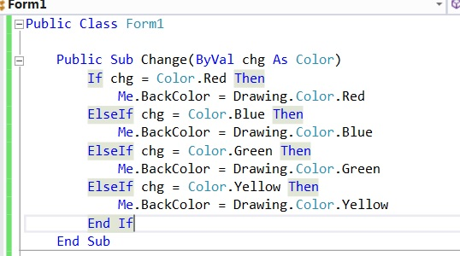
* Now we can program the buttons so that they will change the background color. Double click each button and enter the following code:

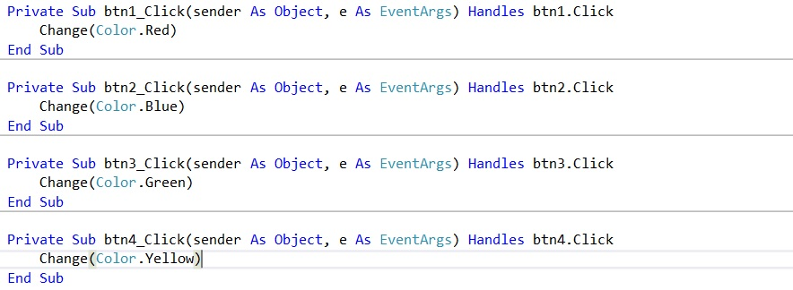

**Step 4)**

* Now that we can change the background color with the buttons, we are going to change the text in the label to match which color is actively selected.
* Select the Label. In the properties pane for the label change the text size to 12pt and set the bold property as true. This will make the label text show up better against the different color backgrounds.

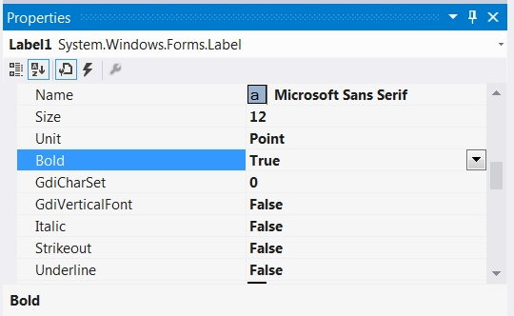

* To change the label text is relatively easy. All we need to do is add a short line to each part of the code belonging to each button press. Add the following:

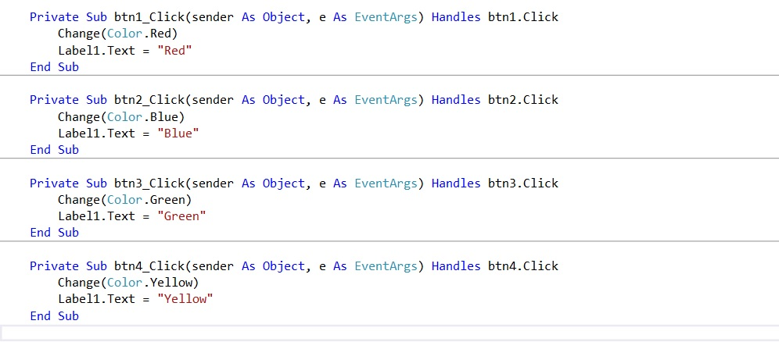

**Step 5)**

* Lastly, we will add a button that clears the current selection for background color and label text. It will effectively be a reset button.
* Replace the text in the button to “Reset”.
* Double click on the button to open the code for it. Add the following code:

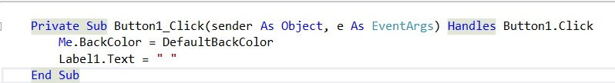

The final layout of the windows form should look like the following when first started or reset:

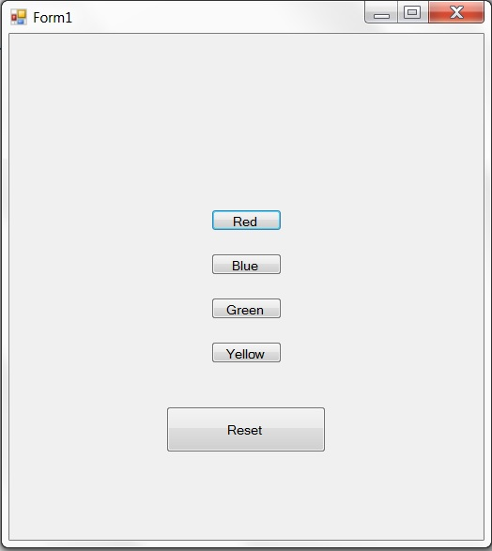

The layout of the form should look like the following when a color is selected:

